REMAP-CAP COVID-19 ACE2 RAS Modulation Domain-Specific Appendix Version 1.0 dated 08 November 2020

Summary
In this domain of the REMAP-CAP trial, participants meeting platform entry criteria with suspected or microbiological testing confirmed COVID-19 will be randomized to receive one of up to three renin-angiotensin system (RAS) blockade strategies, depending on availability and acceptability, or control:
- No RAS inhibitor (no placebo)
- Angiotensin converting enzyme inhibitor (ACEi)
- Angiotensin II receptor blocker (ARB)
- ARB in combination with DMX-200, a chemokine receptor-2 [CCR2] inhibitor (ARB + DMX-200)

At this participating site the following interventions have been selected within this domain:
- No RAS inhibitor (no placebo)
- Angiotensin converting enzyme inhibitor (ACEi)
- Angiotensin II receptor blocker (ARB)
- ARB in combination with DMX-200, a chemokine receptor-2 [CCR2] inhibitor (ARB + DMX-200)
Is the site participating in the COVID-19 ACE2 RAS Domain? YES / NO (If yes, please also indicate participation in the different states in the table below)
Name site:

Name PI:

Date:
Signature:

This DSA applies to the following states and stratum:

Stratum | Pandemic infection suspected or proven (PISOP) |  |  |  |  |  |  |  |  | Pandemic infection neither suspected nor proven (PINSNP)
Core protocol documents | REMAP-CAP Core Protocol + Pandemic Appendix |  |  |  |  |  |  |  |  | REMAP-CAP Core  Protocol
Illness Severity State | Moderate State |  |  |  |  |  | Severe State |  |  | Severe State
Interventions specified in this DSA | No RAS inhibitor  ACEi ARB  ARB + DMX-200 |  |  |  |  |  | No RAS inhibitor  ACEi ARB  ARB + DMX-200 |  |  | Not available
Interventions submitted for approval in this  jurisdiction | - No RAS inhibitor  - ACEi  - ARB  - ARB + DMX-200 |  |  |  |  |  | - No RAS inhibitor  - ACEi  - ARB  - ARB + DMX-200 |  |  | Not available
Interventions  offered at this site |  | Ward |  |  | ICU |  |  | ICU |  | ICU
 | - No RAS inhibitor  - ACEi  - ARB  - ARB + DMX-200 |  |  | - No RAS inhibitor  - ACEi  - ARB  - ARB + DMX-200 |  |  | - No RAS inhibitor  - ACEi  - ARB  - ARB + DMX-200 |  |  | Not available

CONFIDENTIAL Page 1 of 2

Angiotensin converting enzyme inhibitor (ACEi) and Angiotensin II receptor blocker (ARB) Choices

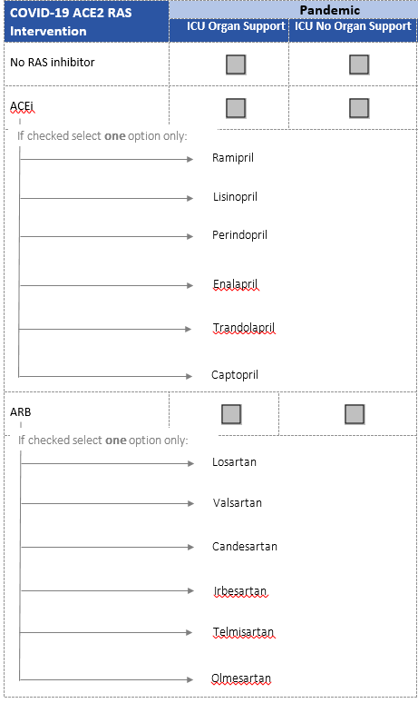

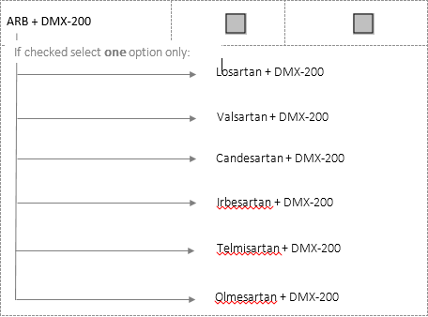

CONFIDENTIAL Page 2 of 2

